Lesson url:

<https://learn.acloud.guru/course/93e6884d-ac98-49b6-a9cd-5e357d2dbb41/dashboard>

Chapter3

Build Automation Gradle

* Build automation is process of converting raw source code in to something deployable
* this can be compiling, running smoke tests, installing dependencies, packaging converting to jar war files

Gradle wrapper

Wrapper is a script that allows gradle to install itself before hand if it is necessary

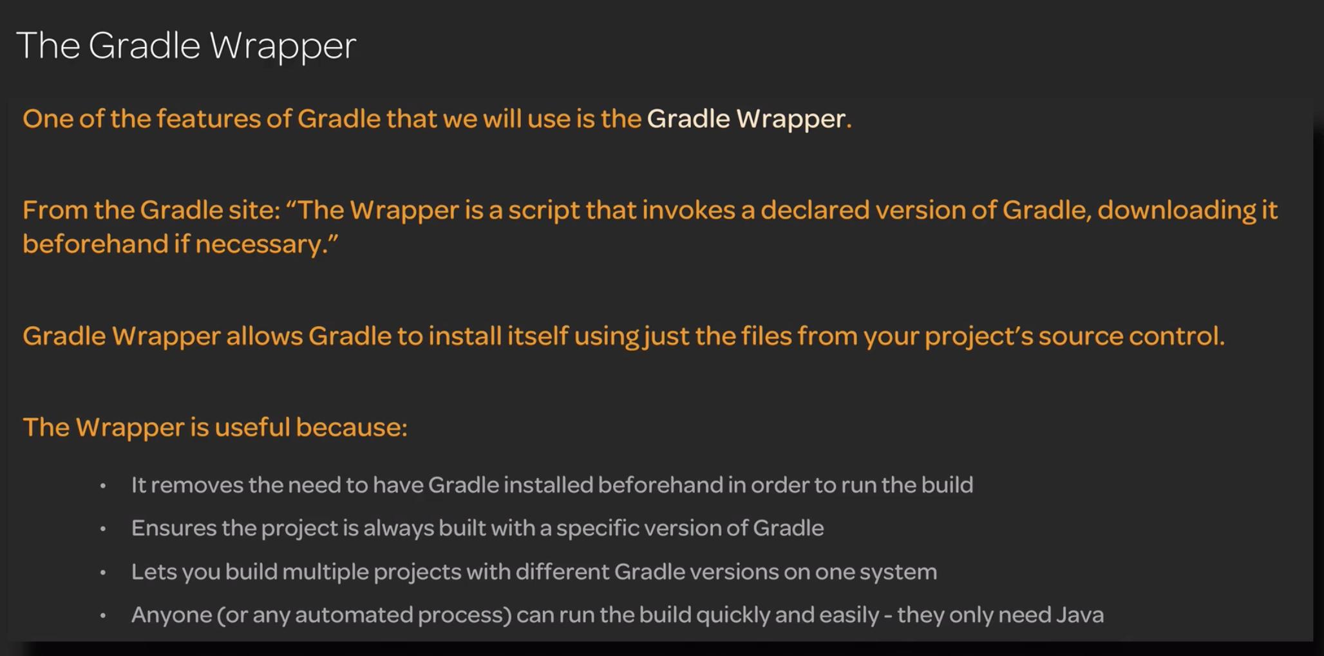

Which basically means if you have gradle installed in your machine and run the gradle wrapper command it downloads some gradle files inside the project files which need to committed into the source control (git), when a developers downloads the repo with the gradle files he doesnot have to install gradle again on his machine to run the build. Some files .gradle file needs to be ignored using .gitignore

* gradle init
* vi build.gradle
* ./gradlew taskname

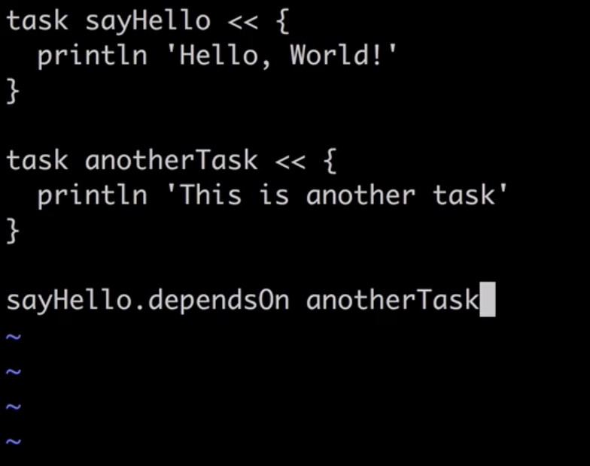

In this way we can create dependencies to run certain task before running some other tasks and result in build error. Example compiling a code needs to be done before performing automation testing on the code.

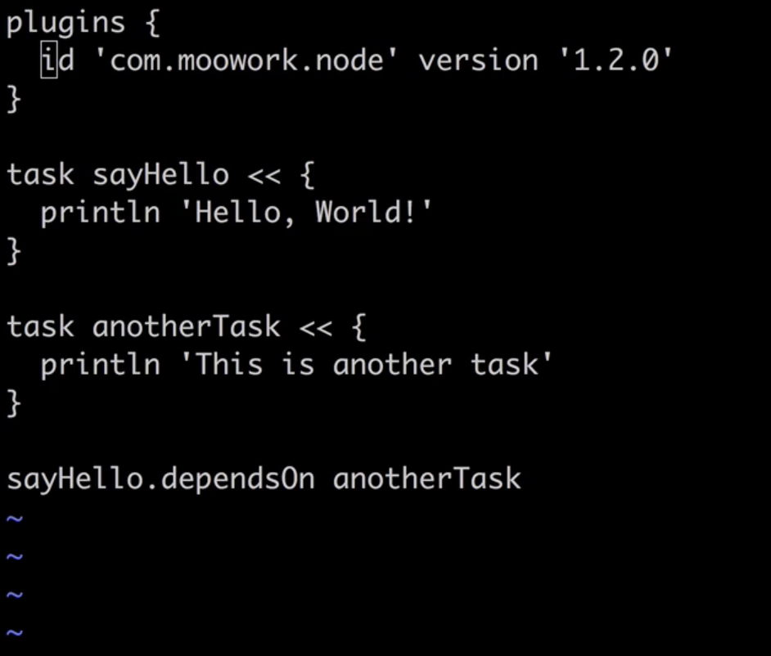

The above app was developed so they added a Node.js plugin to run some tasks

Automated Testing

Project

<https://github.com/linuxacademy/cicd-pipeline-train-schedule-gradle>

* Install gradle
* Install gradle wrapper
* gradle init

pTask: Have build ,ran tests, deployed it using npm

To achieve this I have wrote a task called start instead of build like above in the build.gradle file

Followed all the steps in above project and written a task step instead of started using npm_start and building, testing using npm_build, npm_test

